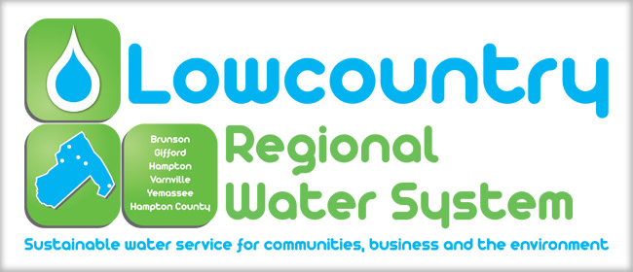
We now offer paperless billing and alerts by email.
If you choose paperless billing, you will no longer receive a bill in the mail. We will send you an email to the email address that you provide stating that your new bill has been generated and it can be viewed and paid by clicking the link provided in the email. Additionally, you can choose to be enrolled to receive alerts by email that pertain to water outages, upcoming dates for disconnections, office closings, etc.
If you choose to continue receiving your bill by mail but would also like to receive alerts by email, you will receive those alerts via the email address that you have provided to us. The alerts will be general messages to all our customers. These alerts may pertain to water outages, upcoming dates for disconnections, office closings, etc.
To Sign Up
Please Complete the Form Below and Return it to
The Lowcountry Regional Water System

Name _____________________________________________ Account Number ___________

Email Address ________________________________________________________________
Please Check if you would like to sign up for the following.
Paperless Billing & Email Alerts
(You will not receive a paper bill. You will receive an email that your bill has been generated and it may be viewed and paid by following the link provided. You will also receive email alerts that may pertain to water outages, upcoming dates for disconnections, office closings, etc. to the email address provided.)
Email Alerts Only
(You will receive email alerts that may pertain to water outages, upcoming dates for disconnections, office closings, etc. to the email address provided. You will continue receiving your bill by mail.)

Signature_____________________________________ Date ______________________

By Signing this form, you are agreeing to the options checked above. You are also certifying that the account number and email address are correct. You are responsible for providing an accurate and current email address. If you need to update your email address you will need to complete and submit a new form.

